Greetings Sault Area Middle School families,
Thank you for your dedication in making sure that students are dropped off and picked up on time at SAMS, we appreciate all of your efforts. When dropping off middle school students, there are expectations that ensure the safety and well-being of all pedestrians and motorists that need to be followed. These expectations are below for your review.
- The intersection of Marquette and Minneapolis is a four way stop. A review of four way stop directions is attached.

- The intersection of Marquette and Minneapolis has a crossing guard for students to cross the intersection safely. No vehicles are to move in the intersection when the crossing guard is in the intersection – this includes any right hand turns.

- Vehicles must pull forward to the end of the school building to drop off students. Please do not stop or park before the crosswalk at the end of the canopy. This prevents traffic from backing into the intersection – keeping parked vehicles and moving vehicles safe.

- Vehicles are not to stop or park in the crosswalk in front of the canopy at SAMS.

- Vehicles are not to double park, or pass vehicles on the left in the drop off lane. This prevents a person or vehicle door from being struck.

We truly appreciate your cooperation and patience in keeping all pedestrians and motorists safe! If there are questions or concerns, please contact Jessica Rondeau, Principal at 906-635-3832.

1. First come, first served.
This applies to the road too. If there is no traffic light but rather a 4-way stop, the first car to arrive at the intersection receives the right of way. It doesn’t matter where the vehicle is located or what direction it is traveling; this rule will always apply when someone has clearly arrived at the stop sign first. However, still be wary of aggressive or distracted drivers that may dismiss this rule.
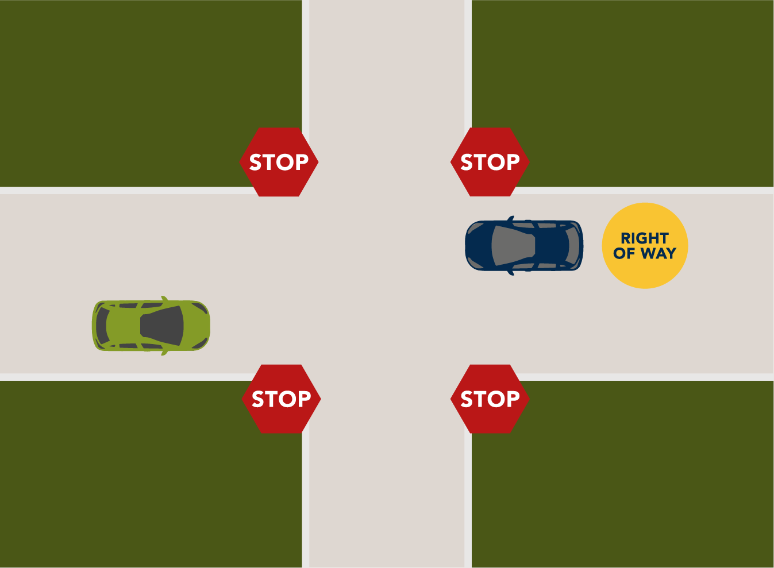
2. Yield to right.
When two vehicles arrive at a 4-way stop at the same time, and are located side-by-side, the vehicle furthest to the right has the right of way. If three vehicles arrive at the same time, the car furthest left should continue to yield until both of the other cars to the right of them have passed.
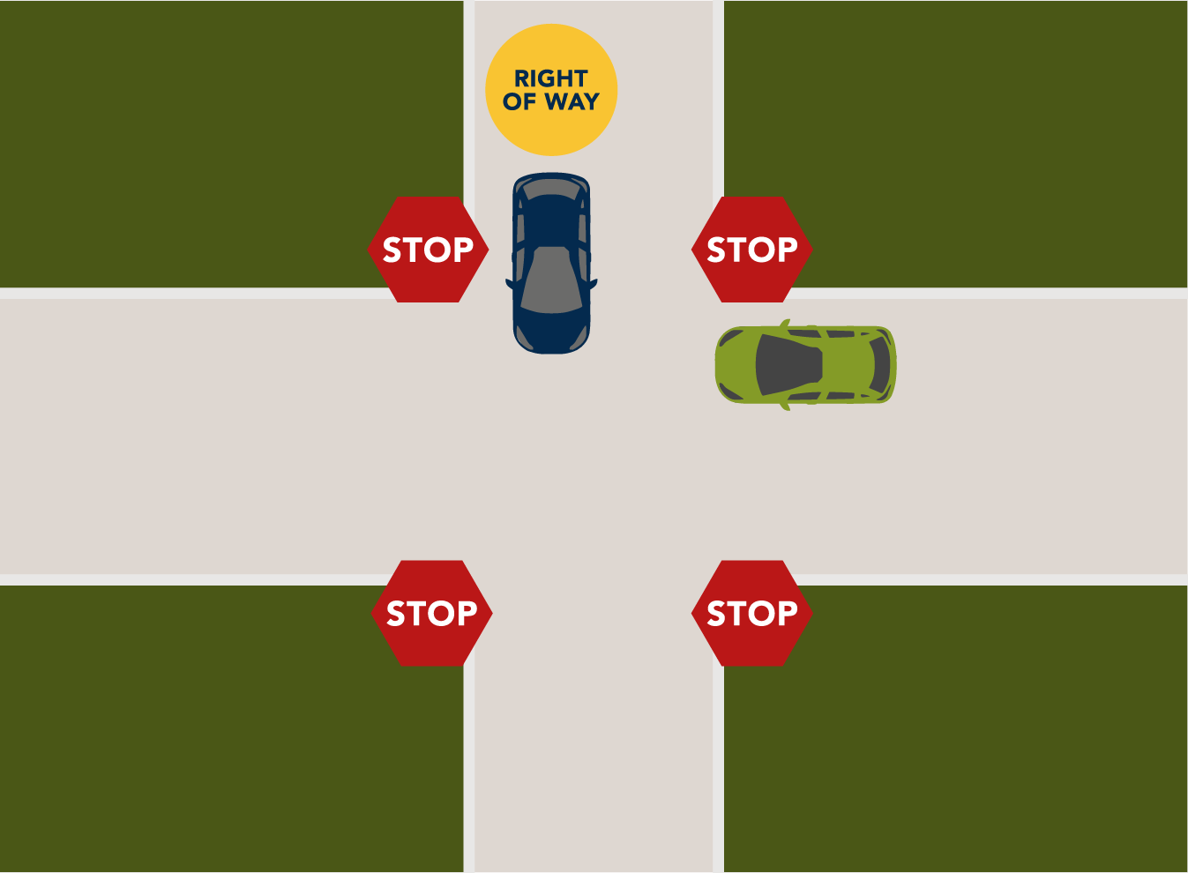
3. Straight over turning.
When arriving to an intersection head-to-head with another vehicle, it is important to use signals. When two vehicles arrive at a 4-way stop at the same time, and they are located head-to-head and one of the vehicles intends to turn and the other intends to go straight, the vehicle going straight has right of way. Keep in mind that if both vehicles are going straight or turning in the same direction, they can both proceed at the same time as they will not cross each other’s path.
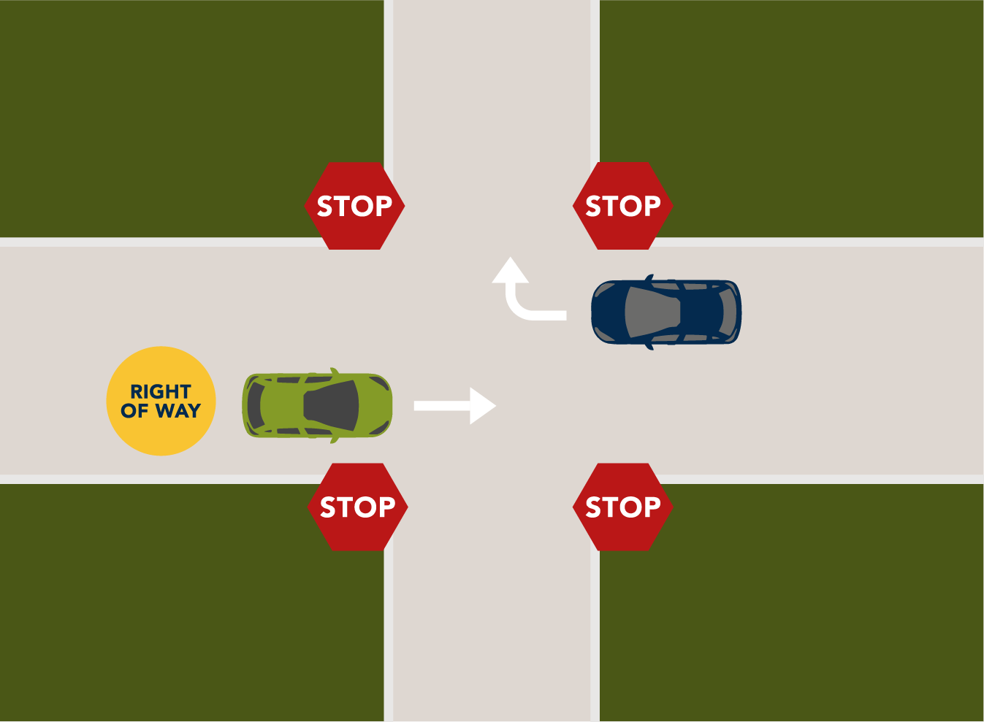
4. Right over left.
When two vehicles arrive at a 4-way stop at the same time, and they are located head-to-head and one of the vehicles intends to turn right and the other intends to turn left, the vehicle turning right has right of way. Move forward slowly before entering the intersection to indicate to other drivers you are making the turn. The driver turning left should wait until the other car has fully passed.
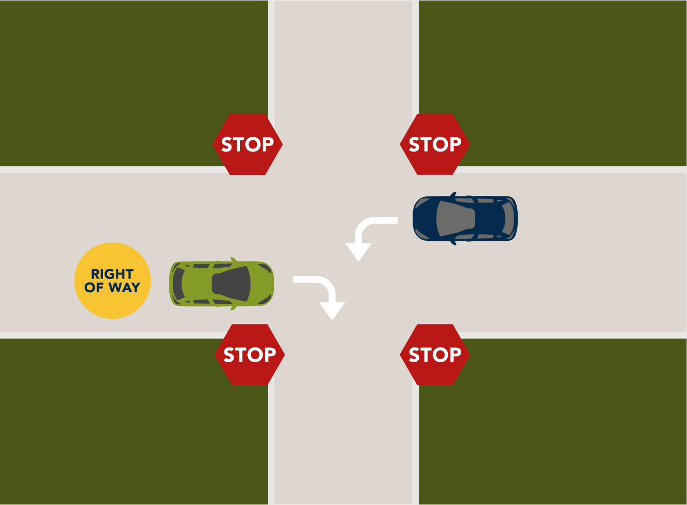
You may be wondering what happens if all four cars arrive at the intersection at the same time? There is no good rule of thumb as to who should go first. However, it is recommended that you wait for the most aggressive driver to make the first move and then proceed with caution using the rules above from there. Overall, it’s important to be patient and alert when approaching a 4-way stop.

